**Design Report**

**Professor:** Micheal Pritchard

**Course:** CST-247

**Student:** Patrick Garcia, Mark Pratt

**Date:**  8/2/2020

**Title:** Milestone 3 Design Report

UML Class Diagrams

*Home*

These views and controller make up the home page of our site. This introductory page simply gives the user a choice between registering or logging in.

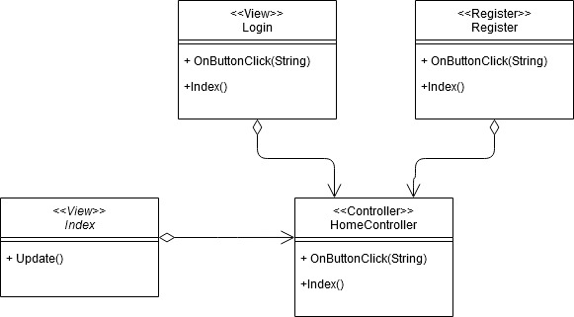

***Login***

These classes, controllers and views are used to allow a user to login into our website by querying our database.

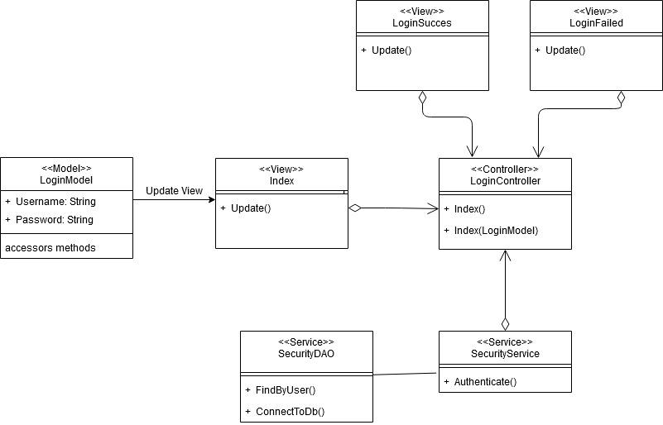

***Registration***

These classes are used to register a new user by saving their information to a database.

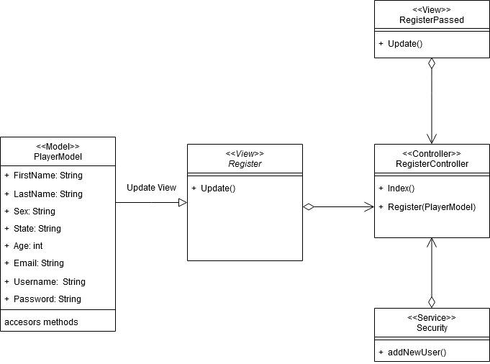

***Playing the Game***

These classes are used together, to display and manage a fully functioning minesweeper game.

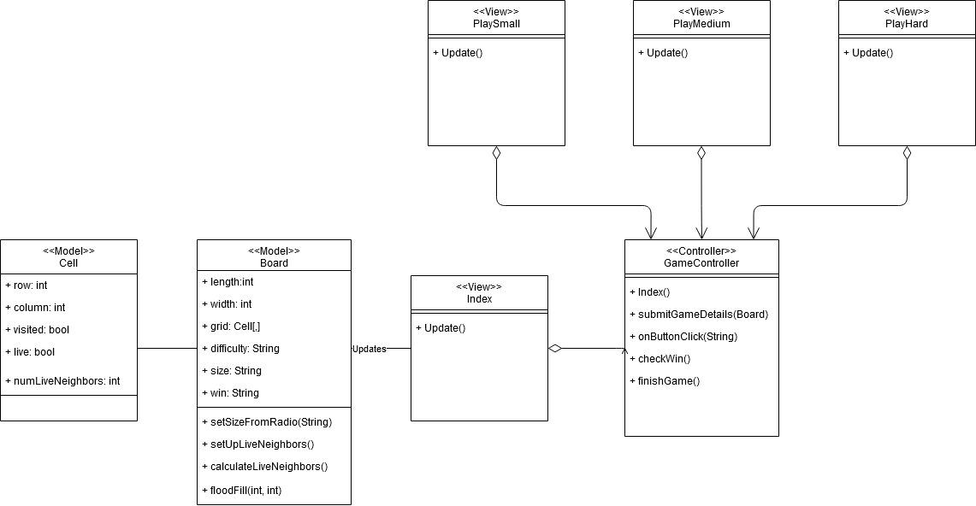

Er Diagrams

Note: Our Er diagram is very simple, because we are in the early stages of development for this program. Our database contains only one table, therefore it has no relationships to other tables yet. This diagram will be updated as the program is completed.

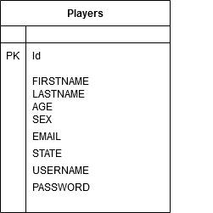

Scrum Retrospective

Date: 8/1/2020

Participants: Patrick Garcia, Mark Pratt

Background: Meeting to discuss what did, or did not improve from week two, to week three.

Note: Meeting results separated into three categories:

* Start Doing: This section includes new practices or methods that we will be adopting in the following weeks.
* Stop Doing: This section includes current practices or methods that we will no longer be using.
* Keep Doing: This section includes current practices or methods that we will continue to do in the following weeks.

Start Doing:

* Start working on projects earlier in the week
* Researching security techniques early in the week.
* Placing all business logic in separate backend service classes to preserve separation.

Stop Doing:

* Nothing pressing this week!

Keep Doing:

* We will continue to communicate regularly throughout the week to ensure the project remains on schedule.
* Holding daily standups will be continued.
* Staying updated within our textbooks to stay updated on learning aspects

Screenshots

Note: These screenshots are included to display the basic functionality of the program. Not every case-scenario will be screenshot, just the main functions of the application.

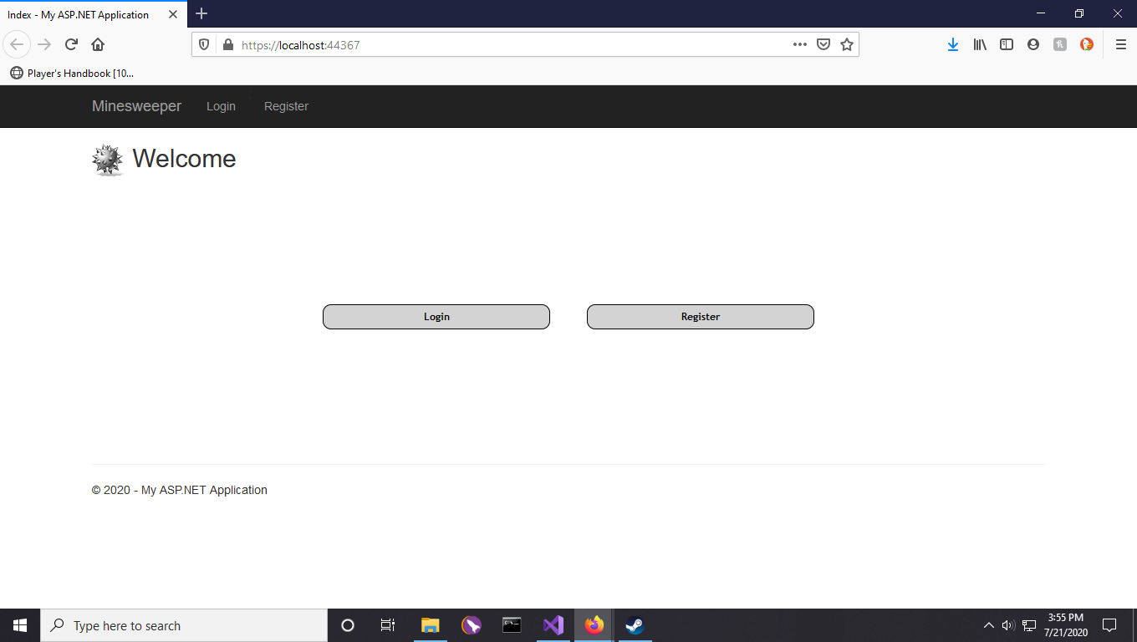

This screenshot shows the main home Page of the application. Clicking login directs you to the login page. Clicking register directs you to the register page. Not the black menu bar above the welcome message. There is a dynamic *logout* link that is only displayed when the user has logged in. This will be demonstrated in the following screenshots.

Note: The main game controller utilizes the “[Authorize]” annotation. This blocks access to the game boards until a user has been logged in. If the *Game* controller is directly accessed through the Url, the program will be redirected to the login page.

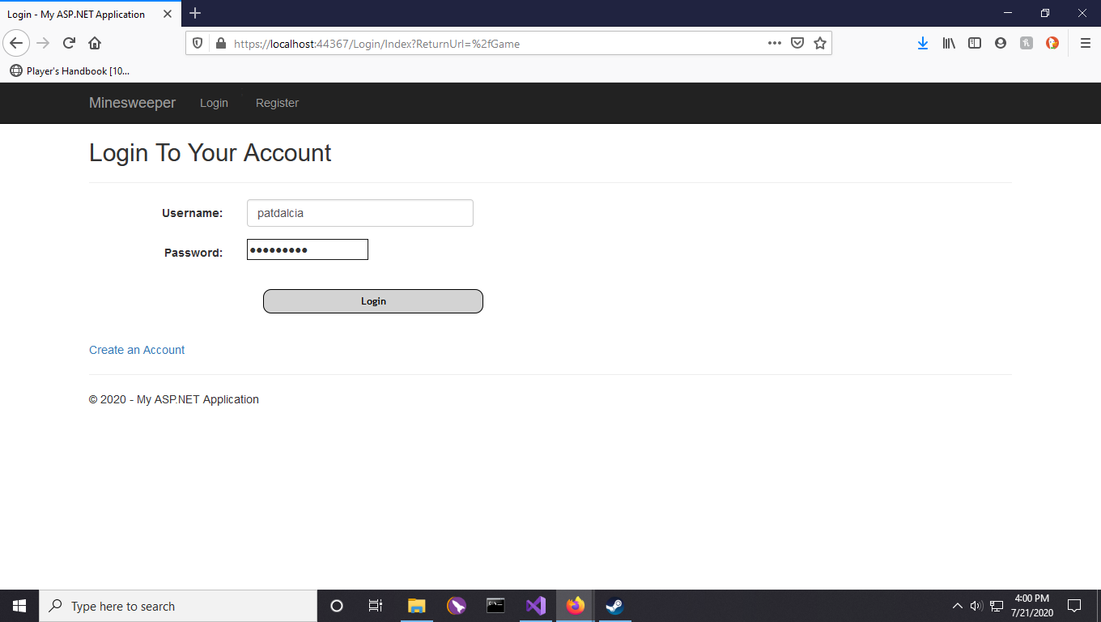

Login page, this page takes login credentials and compares with the contents of the database. If successful, an authentication cookie is created for forms authorization. If unsuccessful user is shown a failure page with the option to register.

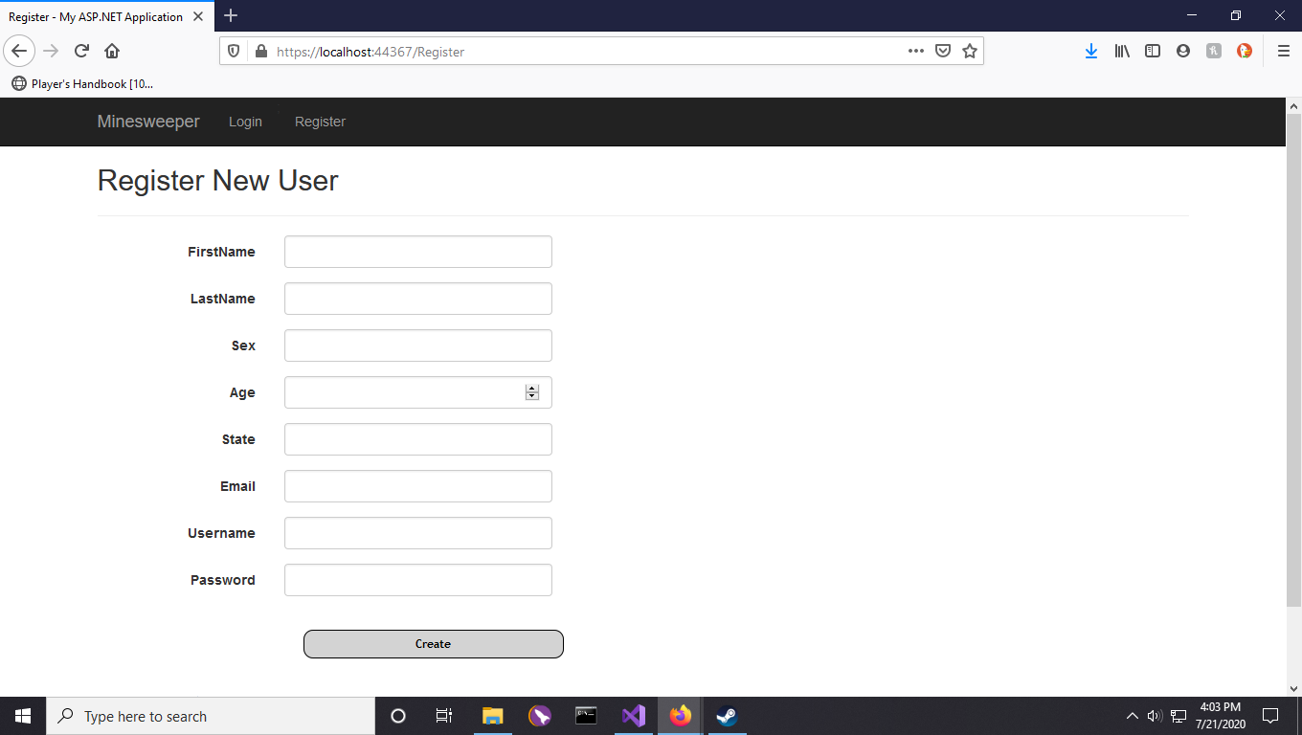

Registration page, registers new user to database after checking if user exists already. If successful user is redirected to the game page after authorization cookie has been created. If unsuccessful, user is redirected to a failure page with the option to try again.

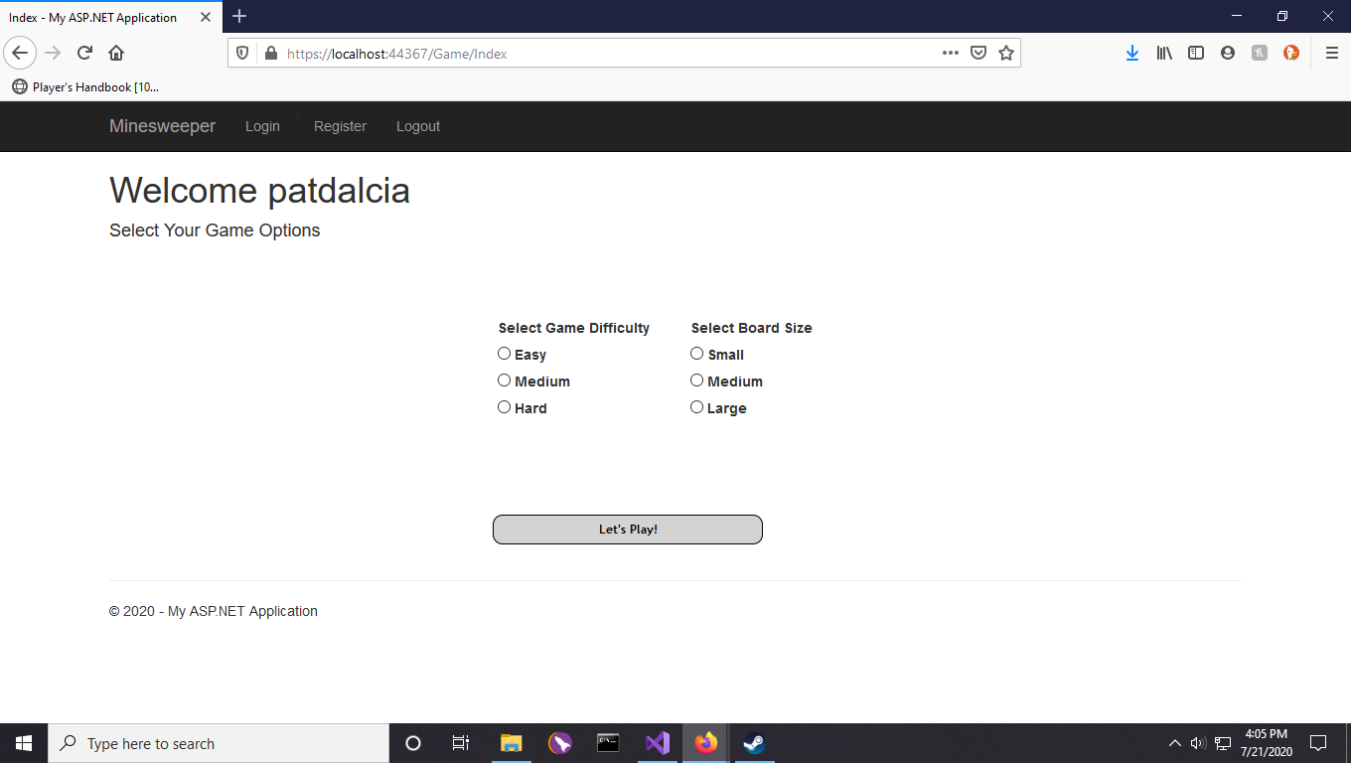

Logged in user. Note the displayed username, and the logout link which is now visible. This page allows the user to set the game options for their game.

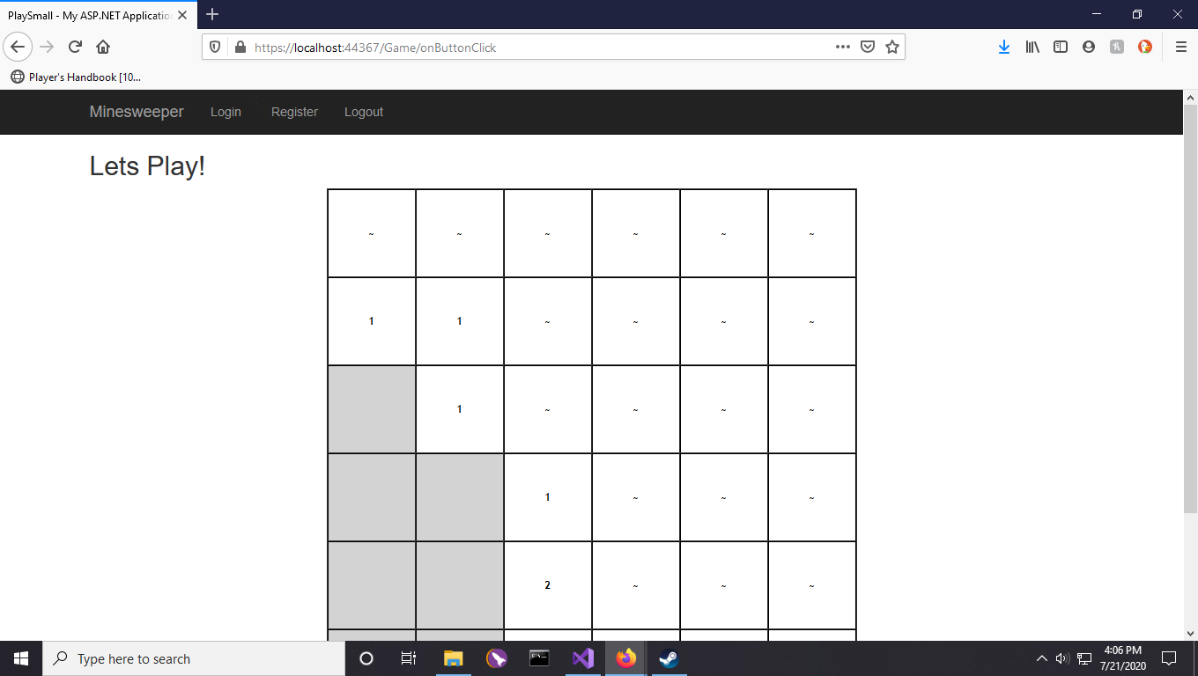

Game in progress on easy in a small map. The other maps will not be shown as they look identical except for a larger number of cells.

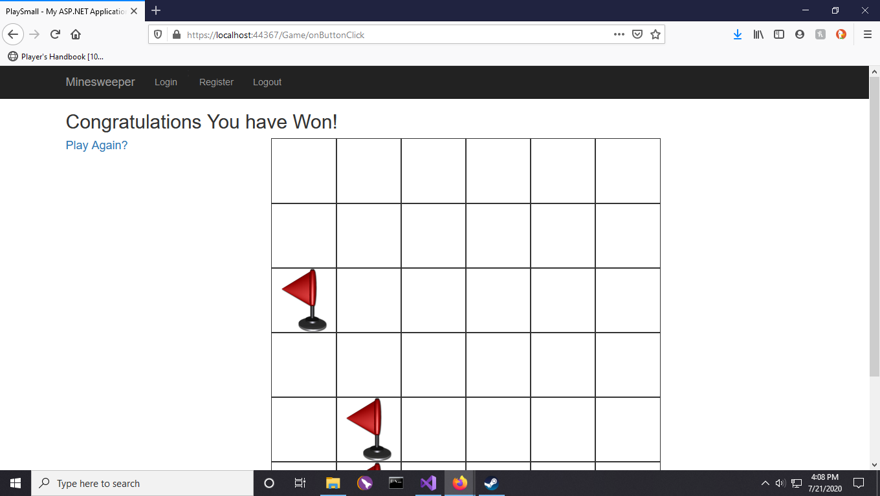

Win

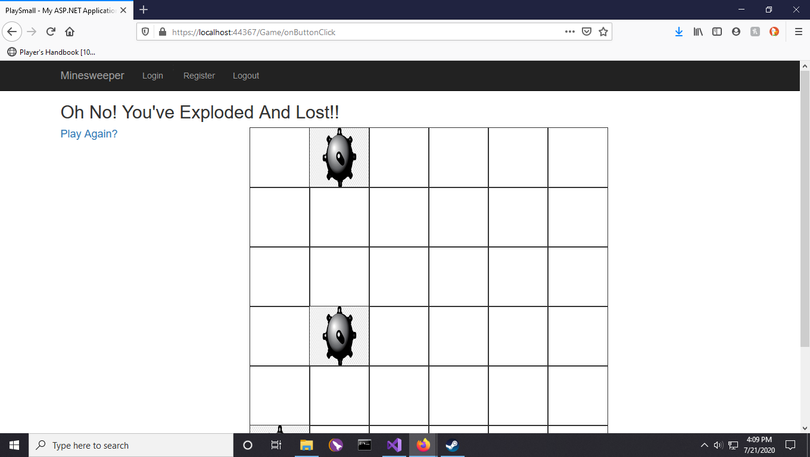

Loss